## Merchant: Tangram Vision

Demo date: Dec 2, 2024  
Scoping start date: Dec 2, 2024

MSA Signature Date: Dec 6, 2024  
Onboarding Kick Off Date: Dec 16, 2024 Said Jan 1 billing terms but I think he’s open to starting earlier

[If Exists] Opt Out Date:   
Go Live Date: Jan 31, 2025 Not set in stone

GTM POC: Paula  
Implementation POC: Royce

ERP: QBO

Tax Integration: No Tax

### 

### Key people at Merchant

### Accountant: Brandon Minor (CEO)

### CFO: Brandon Minor (CEO)

### Customer service rep who is really involved: Brandon Minor (CEO)

* Account Receivable POC: Brandon Minor (CEO)
* Billing POC: Brandon Minor (CEO)

### Etc. Brandon Minor (CEO)

### 

| Notes Sections [Ops International Team to Ignore] *(AE/ Implementation to fill)*   * Info on how merchant bills   + Pilot (1-2 month period)   + Month to month   + Annual   + Some big contracts have tiered usage (units) based pricing escalators * Is there any important merchant relationship information?  1) What is the merchant temperament? SO nice and easy going. He’s a technical Co founder that’s now doing Finance, accounting, sales and marketing. Just recently parted ways with his Co founder.   2) Is there a key POC: (i.e.: who is the buyer/decision maker?)  Just Brandon– he’s really a one man show  3) What are the Tabs features that the key POC cares about?  He loved: key term and renewals extraction, centralization of all docs, automated revenue schedule adjustment (especially with amendments), cash forecasting, ARR waterfall (exactly what he’s trying to show to his investors) |
| --- |

### 

### Company summary *(AE to fill)*

Summary of what company does:  
Tangram Vision is a computer vision AI software leveraged to calibrate robots/machines. They primarily have a software product but will be offering a hardware product soon

Goals (North star)  
*(AE/ Implementation to fill)*

What is the merchant's goal? What pain are we solving? Why are they buying Tabs?

Goals:  
- centralize all contracts   
- eliminate time wasted on manual invoicing   
- eliminate time wasted on reporting   
- ensure accurate reporting to investors   
- charge customers correctly  
  
Pains:  
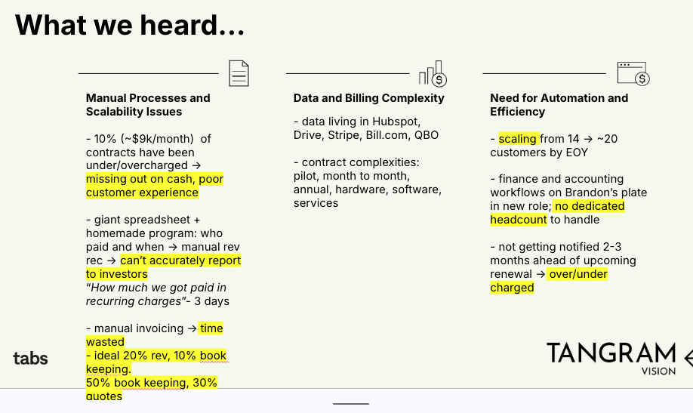  
  
Why Tabs:  
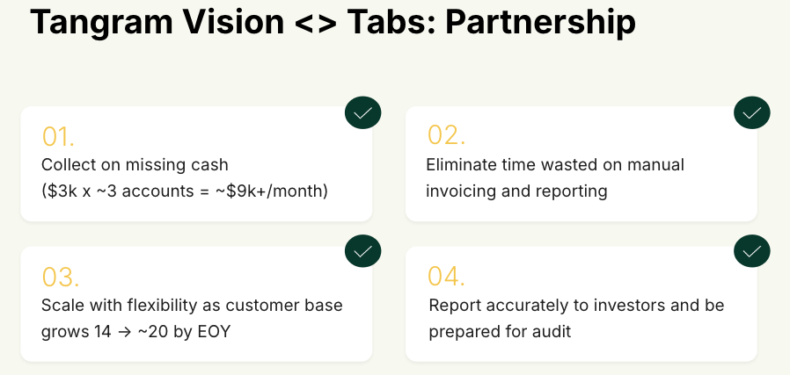

Is there an opt out clause? If so, what is the merchant looking for so they do not exercise it?

No Opt out

### Billing model *(AE/ Implementation to fill)*

* Are there unique things about the customer creation process for this merchant?  
  No
* Information on how merchant bills  
  Month to month or annual
* How contract is broken up
* One off things to know about the merchant  
  N/A

### Contract Processing Steps *(Implementation/Success to fill)*

1. Steps to process
2. Anything to ignore in contracts?
3. Specifics processing things the merchant has requested that may differ by contract (e.g. always back-date invoice date to final day of the month)
4. Default Service Term
   1. If None Listed, Ops Default is 1 Year
5. Default Net Payment Terms
   1. If None, Ops Default is 0
6. Default Billing Frequency
   1. If None Listed, Ops Default is Monthly
7. How do we handle taxes as a line item?
   1. If None Listed, Ops Default is every tax line item becomes a BT

### Events Processing (if necessary) *(Implementation/Success to fill)*

* Any important information on events billing

Integration Items Processing (if necessary)  
*(Implementation/Success to fill)*

* What are the instructions for assigning integration items?
* Example: All Statsig integrations items should be labeled as “Sales”
* Example: All “Pinata” integration items should be labeled as “Software Subscription Bundle” unless otherwise noted by Merchant

Post Processing Communications (if necessary)  
*(Implementation/Success to fill)*

* Does the Ops Team need to notify anyone on the team re: completion of processing batches in Implementation or Active phase?
* Who needs to be notified and when?
  + Example:
    - Who: Customer Success [Azmat Aziz] needs to be notified
    - Where: Messari internal merchant channel
    - When: contracts are processed [Merchant Phase: Active]

### Customer Information *(Implementation/Success to fill)*

* Any important information on specifics customers of this merchant
  + Special memo’s certain invoices require
  + Invoice changes due to merchant/customer relationship

### Feature Requests *(AE/Implementation/Success to fill)*

* FR 1
  + What is it
  + Why it's important
  + Urgency

### Rewatch Calls *(AE/Implementation/Success to fill)*

* Rewatch by dates